Data download instructions:

Fish data:
- https://datras.ices.dk/Data_products/Download/Download_Data_public.aspx
- Select according to this screenshot
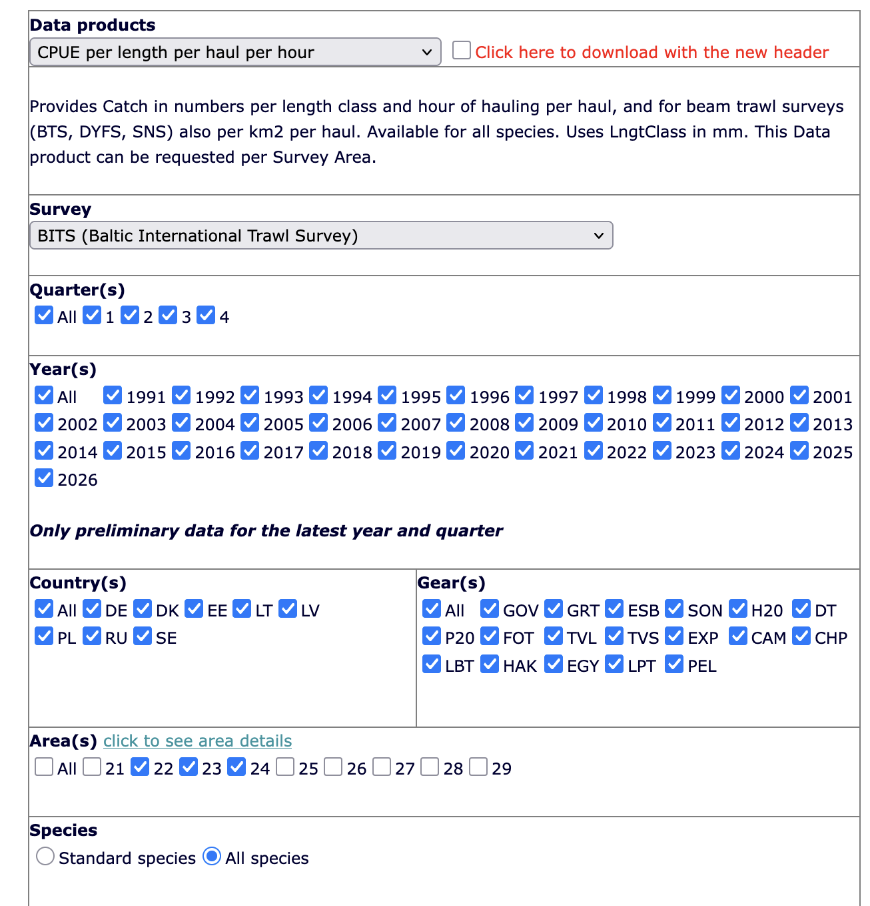
- Select at least 10 species you are interested in

Environmental data:
- https://data.ices.dk/view-map
- Under the tab Dataset themes “Bottle and low resolution CTD” data
- Under the tab advanced search filter for the geographical area (roughly draw a polygon around the Western Baltic Sea, this includes the ICES subdivisions 22 – 24) and filter the time span according to the time span of your fish survey data

Use the ICES shapefiles to attach the official ICES subdivisions by geographical position to your data sets. Then you can compare your data by area if you want to.

